**Ram Gopal Varma Alluri**

**002196886**

**INFO 6205 Program Structures and Algorithms**

**Assignment 1**

Conclusion:

Based on the evidence presented below, the results of this study seem to indicate that the relationship between distance(d) and steps (n) is d ≈ $\sqrt[2]{n}$. More precisely, the distance (d) is somewhat lesser than $\sqrt[2]{n}$

Evidence:

|  |  |  |  |
| --- | --- | --- | --- |
| No of Steps(n) | No of Experiments | Distance Travelled (d) | d ≈ $\sqrt[2]{n}$ |
| 10 | 30 | 3.021565506971396 | true |
| 25 | 30 | 4.8801969932373215 | true |
| 50 | 30 | 7.951082843372185 | true |
| 75 | 30 | 8.843600832900375 | true |
| 100 | 50 | 9.646757877519912 | true |
| 200 | 50 | 14.538182745370937 | true |
| 500 | 100 | 21.006565823532057 | true |
| 750 | 100 | 27.950692948224873 | true |

Considering the given fact i.e. step length of the drunken person is always “1”. These results show that the distance(d) is smaller than $\sqrt[2]{n}$, irrespective of the number of experiments conducted.

Test Cases:

All the given unit test cases are passed. Below is the screenshot for reference

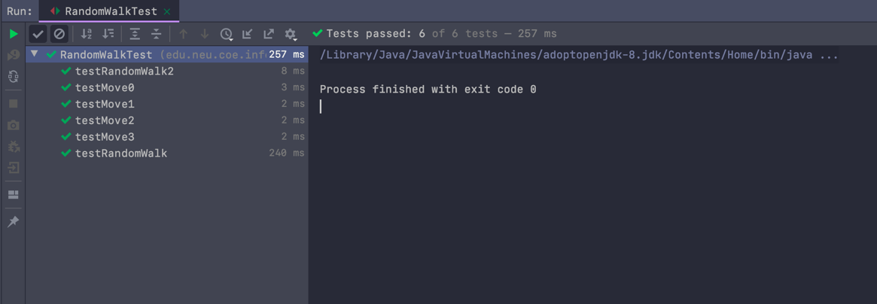

Source Code: ([Link](https://github.com/alluriramgopalvarma/INFO6205/blob/master/Assignment1/src/edu/neu/info6205/randomwalk/RandomWalk.java))

Attached in the directory